ECA5604- 5g/6g communication
Slot A
M.Pregna
192412350

Experiment 9: Massive MIMO Capacity vs SNR and Gain Using MATLAB
AIM: To analyze the performance of a Massive MIMO system by studying channel capacity,
signal-to-noise ratio (SNR), and antenna gain using MATLAB.
Objective 1: Analyze the channel capacity of a Massive MIMO system for different signal-to-noise ratio (SNR)
values using MATLAB. Observe how channel capacity increases with improving signal quality
based on the Shannon capacity principle..
code:
clc;
clear;
close all;
snr = 0:5:30;
snr_linear = 10.^(snr/10);
capacity = log2(1 + snr_linear);
figure;
plot(snr,capacity,'-o','LineWidth',2,'MarkerSize',6);
grid on;
xlabel('SNR (dB)');
ylabel('Channel Capacity (bps/Hz)');
title('Channel Capacity vs SNR');

output:
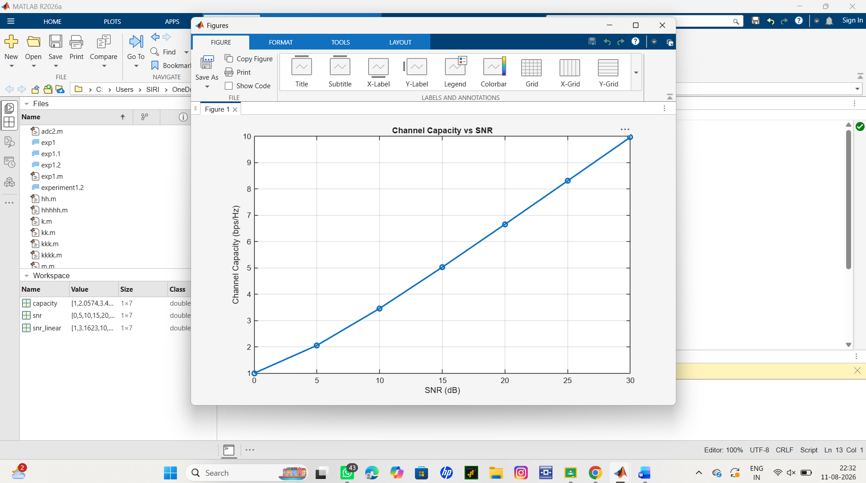

Objective 2:
Analyze the channel capacity of a Massive MIMO system for different signal-to-noise ratio (SNR)
values using MATLAB. Observe how channel capacity increases with improving signal quality
based on the Shannon capacity principle.
Code:
clc;
clear;
close all;
snr = 0:5:30;
snr_linear = 10.^(snr/10);
capacity = log2(1 + snr_linear);
figure;
plot(snr,capacity,'-o','LineWidth',2,'MarkerSize',6);
grid on;
xlabel('SNR (dB)');
ylabel('Channel Capacity (bps/Hz)')

title('Channel Capacity vs SNR'); 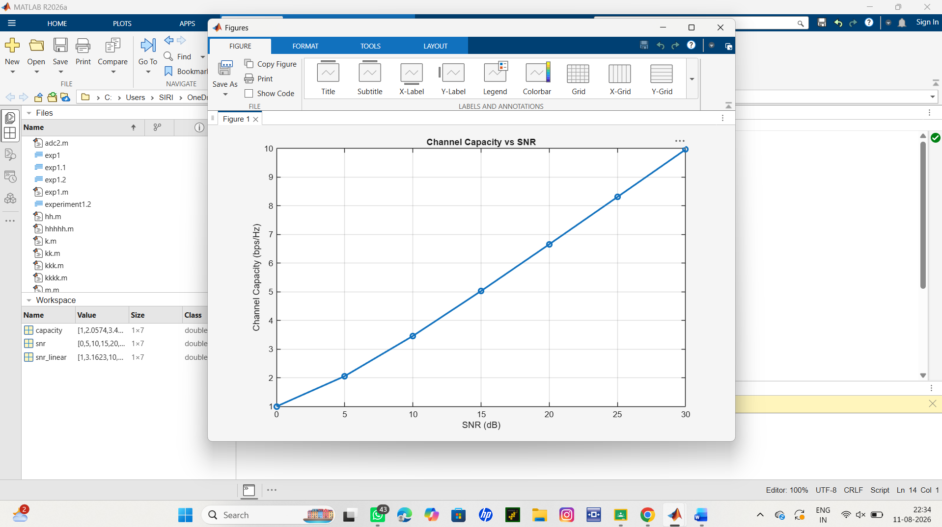
Objective 3:
Bar graph showing Antenna Gain for different antenna array sizes.
Code:
clc;
clear;
close all;
theta = [-60 -30 0 30 60]; % Main Lobe Direction (degrees)
gain = [1 1 1 1 1]; % Constant normalized gain
figure
polarplot(deg2rad(theta), gain, 'o', 'LineWidth', 2)
title('Main Lobe Direction in Analog Beamforming')
output:
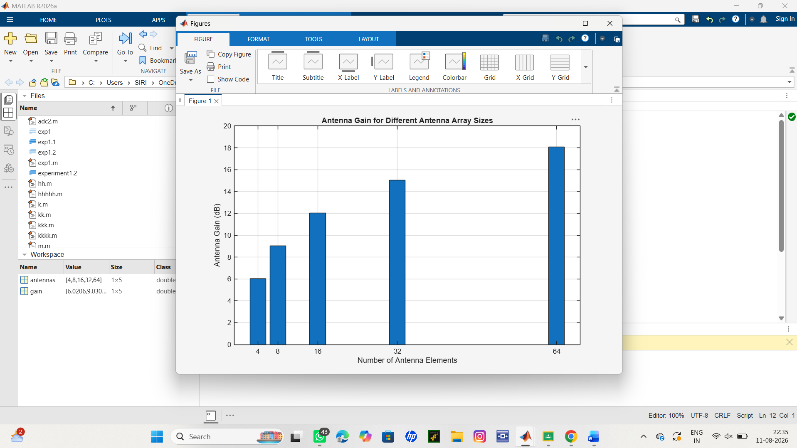
Result:
The MATLAB analysis successfully demonstrated the relationship between channel capacity,
signal-to-noise ratio, and antenna gain in a Massive MIMO system. The results showed that higher
SNR and larger antenna arrays improve communication performance by increasing channel
capacity and directional gain.

